Structural Analysis Task

LAB-1: Loads, Releases, Boundary Conditions and Creating a CIS file

Objective
After This Lab Students will be able to Place dead and live distributed loads on beams. Place concentrated wind loads on one side of the structure. Define member end releases. Define member boundary conditions for the columns and create a CIS file

Part I: Create Load Cases and Combinations

- Open or create a session file and define an appropriate filter for your workspace that includes Grids, Structure, and Structural Analysis for Unit 2.
- Go to the Structural Analysis Task.
- Create an Analysis Model.

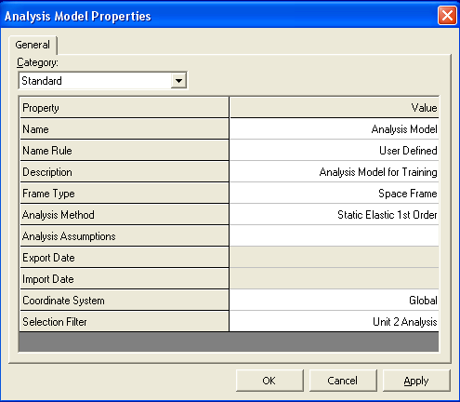

- Select the Create New Load Case command.
- Create a DEAD load.

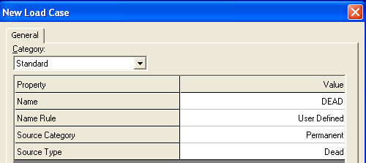

- Create a LIVE load.

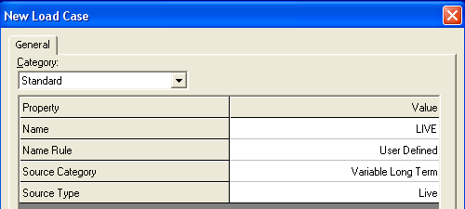

- Create a WIND load.

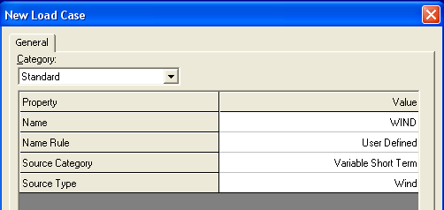

- Create Load Combinations.
- COMB1: Dead + Live with the Factor as 1.0

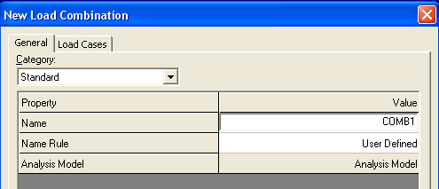

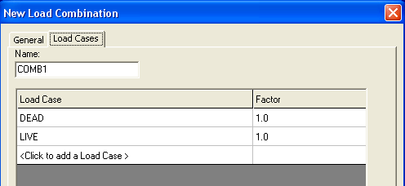

- Create Load Combinations.
- COMB2: Dead + Live + Wind with the Factor of 0.75

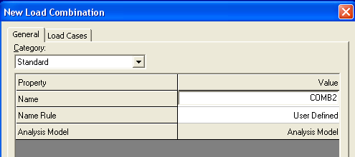

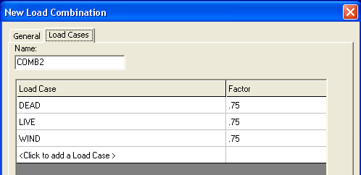

- The Workspace Explorer now includes the Load Cases and Combinations created above on the Analysis Tab.

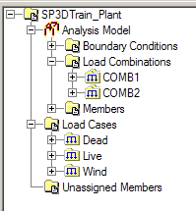

Part II: Place Live and Dead Loads

- Click Place Distributed Load.
- Define the following load for the beams at Elevation 18’-0”:
Load Case: DEAD
Load: Force Z
Reference: Global
Position as: Relative
Start Position: 0
End Position: 1
Start and End Magnitude: -0.65 kpf
Select all beams at Elevation 18’-0” and click Finish. Loads will be placed as shown below:

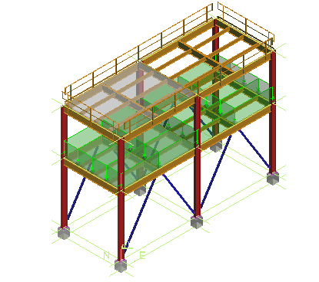

- Define the following distributed load for the beams at Elevation 30’-0”:
Load Case: DEAD
Load: Force Z
Reference: Global
Position as: Relative
Start Position: 0
End Position: 1
Start and End Magnitude: -0.100 kpf

- Select the beams running north/south at Elevation 30’-0” and click Finish.
- Loads will be placed as shown below:

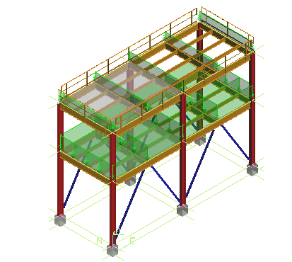

- Change the Magnitude to –0.200 kpf and apply this to the 4 primary beams running east/west at Elevation 30’-0”.
- Change the Load Case Name to Live and the Magnitude to -.220 kpf and apply the load to the 4 primary beams running east/west at Elevation 30’-0” and the interior framing members
- Change the Magnitude to –0.110 kpf and apply the Live Load to the 3 beams running north/south at Elevation 30’-0”

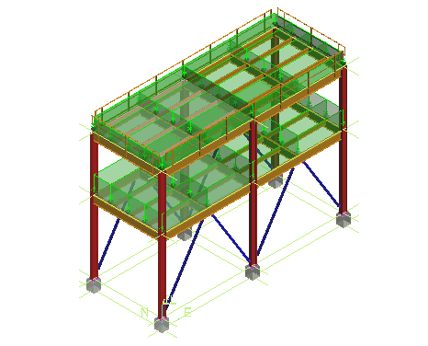

Part III: Place Wind Loads
- Click Place Concentrated Load.
- Define the load as:
Load Case: WIND
Load: Force Y
Reference: Global
Position as: Relative
- Place concentrated wind loads in the X direction on the south side of the structure with the following magnitudes:
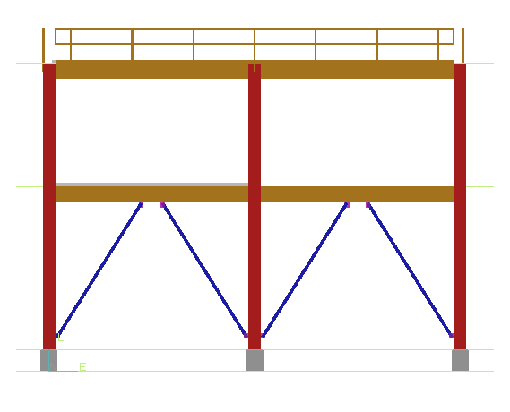
.75k

.75 k

2.0k

.75k

3.0k
7.5k

3.0k

Load representation:

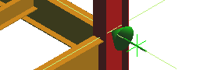

Part IV: Set Member Releases

- Select all beams in Unit 2 with Locate Filter set to Member Parts.
- Select Edit -> Properties in Menu to open the Properties dialog box.
- Choose the End Releases Category.
- Set Start and End Member Release to Free: RY, RZ.

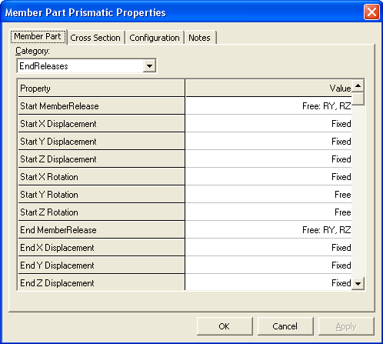

Part V: Place Boundary Conditions

- Create a filter to include all member parts in Unit 2. Select the Analysis Model in the Workspace Explorer. Apply the filter to the Analysis Model.
- Select Place Boundary Conditions.
- Select Frame Connections at the bottom of the first floor columns
- Set the Type to Fix: X,Y,Z,RZ
- Select Finish. Boundary Conditions are placed.

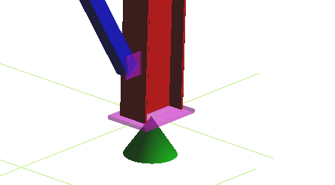

Part VI: Export Analytical Model and Update from Analysis

- Select File -> New Mapping File
Note: First you need to create a mapping file. The mapping file must be used if the third party analysis program you are using calls the section standard a different name from what is delivered with SmartPlant 3D's mapping file. For example, STAAD calls its section standard 'AISC EDI Standard Nomenclature'. Therefore, the line in the mapping file that maps these two Section Standards must be changed from <Standard name="AISC-LRFD-3.0" externalname="AISC-LRFD-3.0". externalorganization="AISC" externaldate="2002" externalversion="3.0" /> to <Standard name="AISC-LRFD-3.0" externalname="AISC EDI Standard Nomenclature"externalorganization="AISC" externaldate="2002" externalversion="3.0" /> in order to get the section sizes updated.
Name the mapping file as follows:
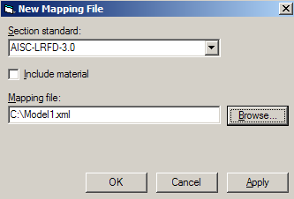
- To create a CIS file, select File - Export - Analytical Model.
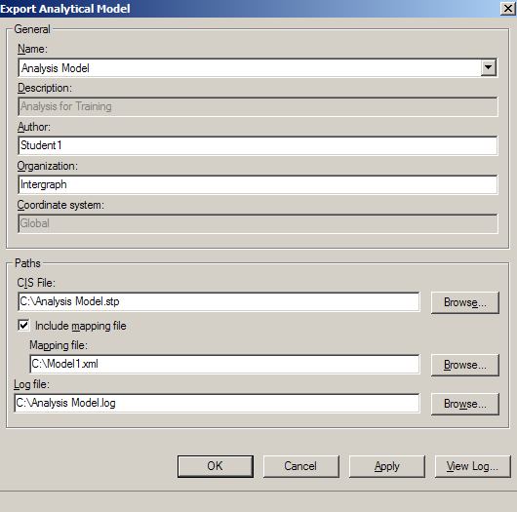
- To update from a CIS file, select Update from Analysis/Design.

